Name: ______________________________________ | Date: ___________________


Baseball Assessment 1

At each level of organized baseball, there are rules in place about what type of bat and ball can be used. These rules help ensure the game play remains competitive, fair, and fun. The type of bat and ball are the two major factors that game organizers can control. But there are a lot of other factors that people claim also have a big impact on game play that cannot be controlled, such as weather conditions, location of the stadium, and the strength of the players.

Answer the prompts below to figure out how these factors could impact the game of baseball.

Weather Conditions and Pitch Speed
To the right is a graph that shows how pitch speed is affected by wind speed. The line on the graph shows the general relationship between wind speed and pitch speed. Points A, B, and C represent three of the same type of fast pitch all thrown at the same initial speed from a pitcher’s fingertips, but under different wind conditions. | 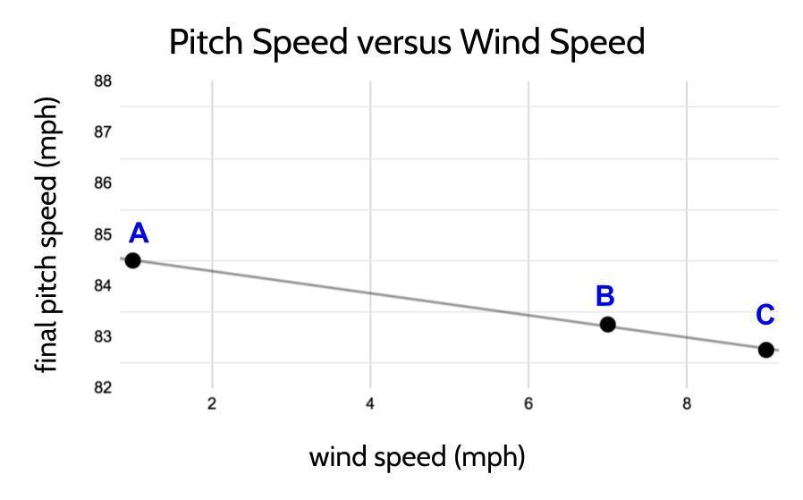  Data source: Kagan, D. (nd). The physics of pitching in the wind. Retrieved from: https://physics.csuchico.edu/baseball/Pubs/PitchingWindLong.pdf

Question 1) Draw three different free-body diagrams (A, B, and C), one for each point marked on the graph. In each free-body diagram, show all the contact forces on the ball after the ball has left the pitcher’s hand. Draw arrows to show the relative strength of forces on the ball. Make sure to include the relative strength and direction of the forces on the ball due to its interaction with the air.

A   | B | C

Question 2) Use your free-body diagrams on the previous page to help answer this question: If all three pitches (A, B, and C) had equal amounts of KE when they left the pitcher's hand, would they all have the same amount of KE when they reach home plate? Why or why not?

Question 3) How would you design an investigation using materials we have used in class to collect evidence for all 3 pitches to support or refute your claim for question 2? List the items and objects you will use in your investigation. Then describe the procedures for setting up and carrying out your investigation.

The items and objects I will use in my investigation:

Baseball items | Classroom items used to simulate baseball items
Bat
Pitcher
Ball
Wind

Other items needed to collect measurements and data:

My plan for setting up and carrying out my investigation:

Representing and Explaining the Relationships between Bat Speed and Bat Mass

The data table below shows how fast a major league power hitter can swing a bat with different amounts of mass. The mass of the bat was the independent variable in this investigation, and the speed of the bat swing was the dependent variable.
  Mass of the bat (grams) | Bat swing speed (mph)
  284 | 74
  340 | 70
  652 | 71
  907 | 62
  964 | 62
  1191 | 61
  1361 | 57
  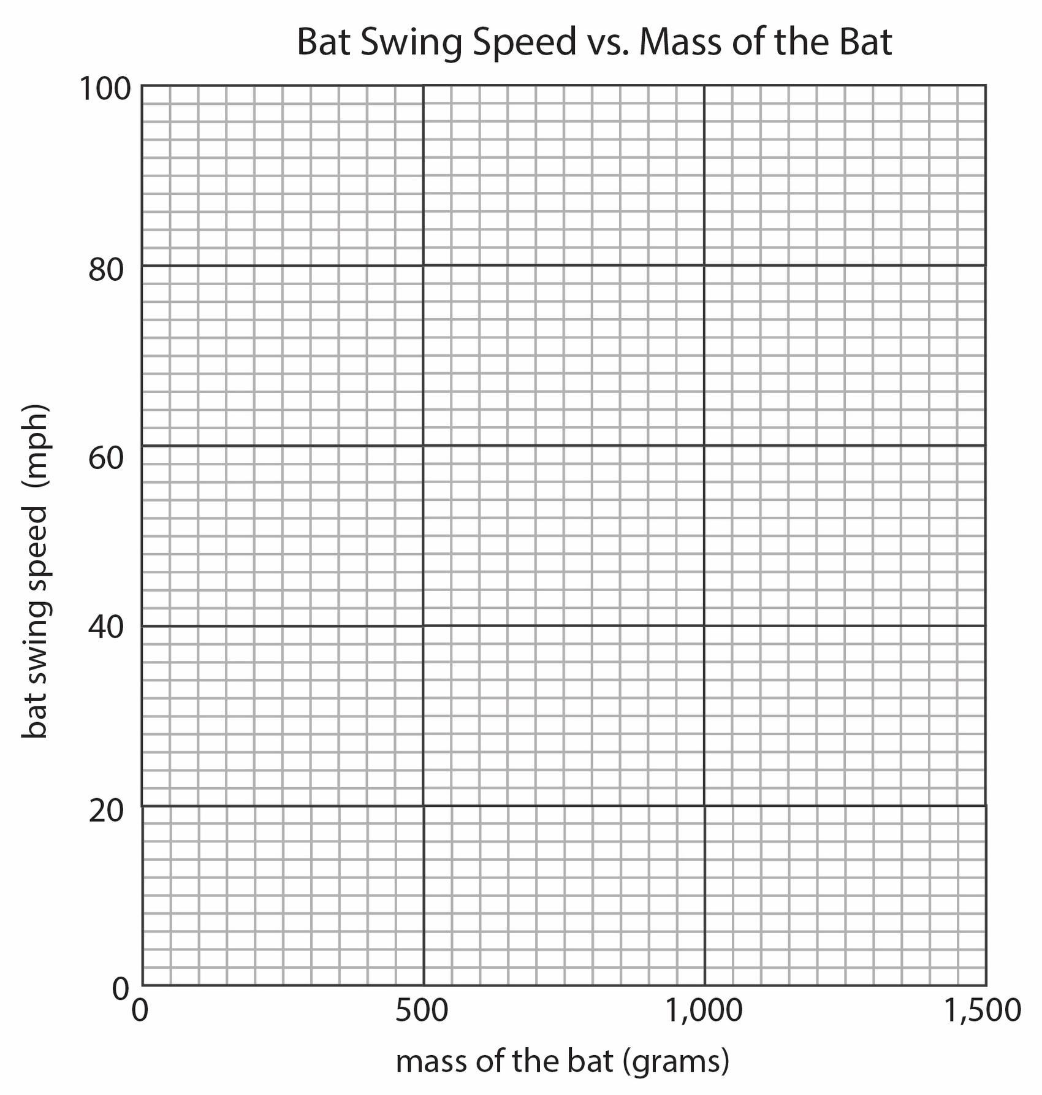
Question 4) Make a coordinate plot of the data from the table above.

Question 5) After graphing your data, draw a line of best fit for it.

Question 6) Use your line of best fit to predict how fast a player could swing a bat with a mass of 779 grams. Record your prediction here: ____________________________

Question 7) If a batter can apply the same amount of maximum force from their hands to each bat to swing it, why would the speed of the bat swing decrease as the mass of the bat increases? Explain this in terms of a chain of cause and effect using forces, energy transfer, and kinetic energy.

What has a bigger effect on kinetic energy of the bat and the ball--increasing the speed of the bat or increasing the mass of the bat?
  Bat weight (g) | Speed of ball after contact (mph)
  570 | 68.5
  710 | 73.0
  850 | 76.2
  990 | 78.6
  1,140 | 80.4
  Bat swing speed (mph) | Speed of ball after contact (mph)
  20.5 | 60.2
  27.3 | 68.8
  34.3 | 76.2
  41.0 | 83.8
  47.9 | 91.4
Question 8) Use the data from the tables above to determine which has a bigger effect on speed of the ball after it is hit: increases in the mass of a bat or increases in the swing speed of the bat. Show any calculations you do to determine which has a bigger effect.

Question 9) Some baseball stadiums (such as Coors Field in Denver, Colorado, which is the home stadium for the Colorado Rockies) are located at much higher altitudes than most stadiums. Coors Field is 5,200 feet (almost a mile) above sea level. At this higher altitude there are fewer air particles in a given volume of air than at lower altitudes. Assume that the data shown in the two data tables in question 8 were collected at a stadium close to sea level (lower elevation). How would you expect the patterns in both tables to compare if you collected new data on bat weight vs. speed of ball after impact and bat swing speed vs. speed of ball after impact at Coors Field, where the air is less dense than air near sea level? Why?

Does the type of bat affect the amount of kinetic energy in the bat and ball?
Some people think it’s important to have rules about the type of bats that players can use. For example, in major league baseball, players are only allowed to use wooden bats, while in NCAA baseball, bats made from metal and other composite materials are allowed. Titanium bats, however, are banned in most baseball clubs.
A coach argues that the reason for this is that the material the bat is made of causes it to produce higher peak forces in a collision than other bats because it deforms less in a collision. | 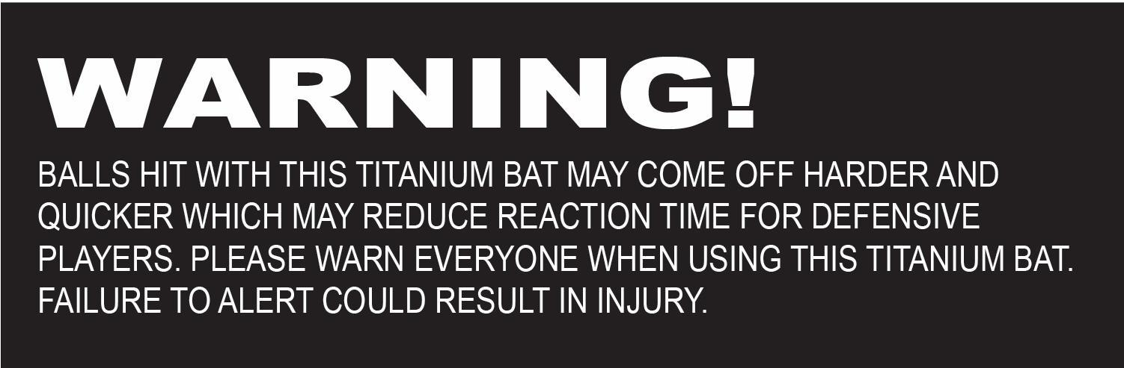  Warning shown on the bat label

Question 10) Does the warning on the bat label shown above support both parts of the coach’s argument about forces and deformation?

Question 11) Do you think that objects or materials that deform less in a collision spring back quicker or slower than objects that deform more? Why or why not?

Question 12) If you were playing baseball against another team and had all the data above for the other team and the conditions for that day, what single factor (wind speed and direction, elevation of the stadium, bat mass, bat swing speeds of players, bat material) would you consider the most when adjusting your game play? Why?

